Assigement-9(Nov 20-11-2018)

1. Diagram:

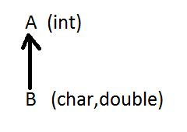

Program:

**class** A

{

A(**int** a)

{

System.***out***.println("A is Integer Value :"+a);

}

}

**class** B **extends** A

{

B(**char** c,**double** d,**int** a)

{

**super**(a);

System.***out***.println("C is Character Class:"+c);

System.***out***.println("d is Double Integer:"+d);

}

}

**public** **class** Test {

**public** **static** **void** main(String[] args) {

B obj=**new** B('s',23.45,123);

}

}

Output:

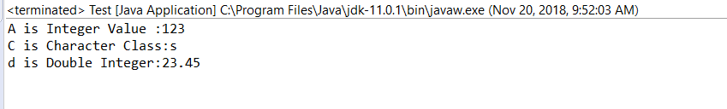

1. Diagram:

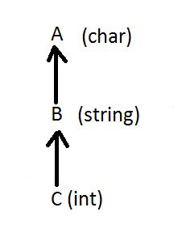

Program:

**class** E

{

E(**char** k)

{

System.***out***.println("E is Character Class:"+k);

}

}

**class** F **extends** E

{

F(String s,**char** k)

{

**super**(k);

System.***out***.println("F is String Class:"+s);

}

}

**class** G **extends** F

{

G(**int** x,String s,**char** k)

{

**super**(s,k);

System.***out***.println("G is Integer Type:"+x);

}

}

**public** **class** Test1 {

**public** **static** **void** main(String[] args) {

G obj=**new** G(10,"Karimulla",'k');

}

}

Output:

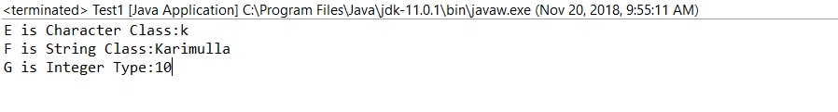

1. Diagram:

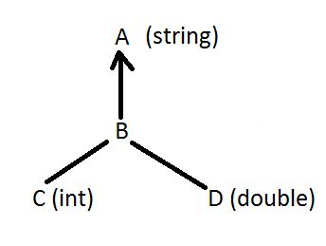

Program:

**class** P

{

P(String s2)

{

System.***out***.println("P is String Character:"+s2);

}

}

**class** Q **extends** P

{

Q(String s2)

{

**super**(s2);

System.***out***.println("Q is String Character:"+s2);

}

}

**class** R **extends** Q

{

R(**int** z,String s2)

{

**super**(s2);

System.***out***.println("R is Integer Value:"+z);

}

}

**class** T **extends** Q

{

T(String s2,**double** j)

{

**super**(s2);

System.***out***.println("T is Double Value:"+j);

}

}

**public** **class** Test2 {

**public** **static** **void** main(String[] args) {

R obj=**new** R(124,"Mulla");

T Obj1=**new** T("Mahesh",24.52);

}

}

Output:

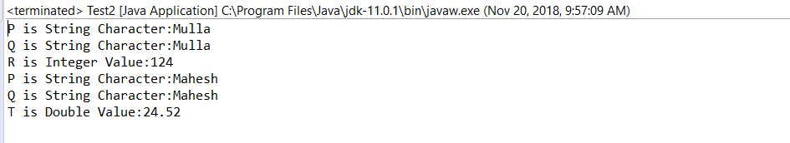

1. Write a java program to compare two strings character by character and print the location of character which is matched

Program:

**public** **class** Split {

**public** **static** **void** main(String[] args) {

String s1="Hyderabad";

String s2="vamsidhar";

**char** ch[]=s1.toCharArray();

**char** ch1[]=s2.toCharArray();

**for** (**int** i = 0; i < ch.length; i++) {

**for** (**int** j = 0; j < ch1.length; j++) {

**if**(ch[i]==ch1[j])

{

System.***out***.println("The Matched Character:"+ ch1[j]);

System.***out***.println("The index of Matched:"+ j);

}

}

}

}

}

Output:

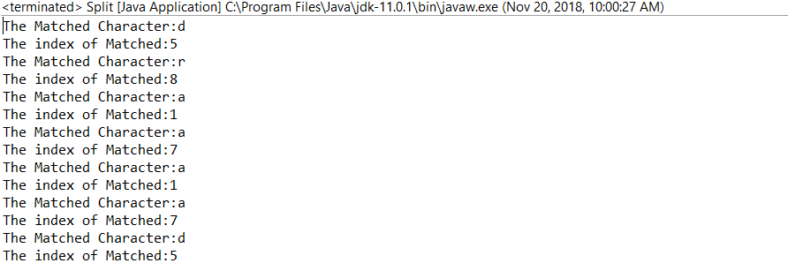

1. Write a java program to find the no of times string “there” repeated in the following string----(when there is a will,there is away)

Program:

**public** **class** Split2 {

**public** **static** **void** main(String[] args) {

**int** c=0;

String s="when there is will there is a way";

String ar[]=s.split(" ");

**for** (**int** i = 0; i < ar.length; i++) {

**if**(ar[i].compareTo("there")==0)

{

c++;

}

}

System.***out***.println("No Of Times Repeated:"+c);

}

}

Output:

